**NANDHA COLLEGE OF TECHNOLOGY**

**ERODE- 638 052**



**DEPARTMENT OF INFORMATION TECHNOLOGY**

**IT3401– WEB ESSENTIALS**

(Regulations 2021)

**FOURTH SEMESTER**

(ACADEMIC YEAR 2022-23)

***ASSIGNMENT / CASE STUDY REPORT – I***

**HTML & CSS PROGRAMS**

|  |  |
| --- | --- |
| **REGISTER NUMBER** | **732121205016** |
| **NAME OF THE STUDENT** | **C.K.DHARUN** |
| **SUBMITTED ON** | **10.03.2023** |
| **MARKS OBTAINED** |  |
| **STAFF SIGN WITH DATE** |  |

**A GOOGLE WEBPAGE CLONE**

**HTML CODE:**

<!DOCTYPE html>

<html>

<head>

<title>My Google</title>

<link href=**"style1.css"** type=**"text/css"** rel=**"stylesheet"**>

</head>

<body>

<div class=**"main"**>

<div class=**"google-logo"**>

<img src= **"https://storage.googleapis.com/gd-wagtail-prod-assets/original_images/evolving_google_identity_share.jpg"** width=**"320"** height=**"240"**/>

</div>

<div class=**"buttons"**>

<button>Google Search</button>

<button>I'm Feeling Lucky</button>

</div>

<div class=**"search-bar-outer"**>

<input type=**"text"** >

</div>

<div class=**"SignInButton"**>

<button>Sign In</button>

</div>

<div class=**"app-logo"**>

<img src=**"index.png"**>

</div>

<ul class=**"img-gm"**>

<li> <a href=**"https://www.google.com/gmail/about/#"** class=**"c"**>Gmail</a> </li>

<li> <a href=**"https://www.google.co.in/imghp?hl=en&tab=wi&ogbl"** class=**"c"**>Images</a> </li>

</ul>

</div>

</body>

</html>

**CSS CODE:**

**.**main **{**

**position: absolute;**

**top : 0;**

**width : 100%;**

**height: 50%;**

**}**

**.**google-logo **{**

**margin-top: 10em;**

**text-align: center;**

**margin-bottom: 5em;**

**}**

**.**google-logo img **{**

**width: 50%;**

**height: auto;**

**}**

**.**search-bar-outer**{**

**position: relative;**

**text-align: center;**

**bottom: 150px;**

**}**

**.**search-bar-outer input**{**

**height: 50px;**

**width: 520px;**

**border-radius: 25px;**

**padding: 20px;**

**border: 1px solid #ccc;**

**box-shadow: 1px 2px 3px #ddd;**

**}**

**.**buttons **{**

**position: relative;**

**text-align: center;**

**bottom: 40px;**

**}**

**.**buttons button**{**

**margin-left: 8px;**

**border-radius: 2px;**

**cursor: pointer;**

**font-family: Arial;**

**font-size: 13px;**

**color: #757575;**

**border: 1px solid #eee;**

**font-weight: 600;**

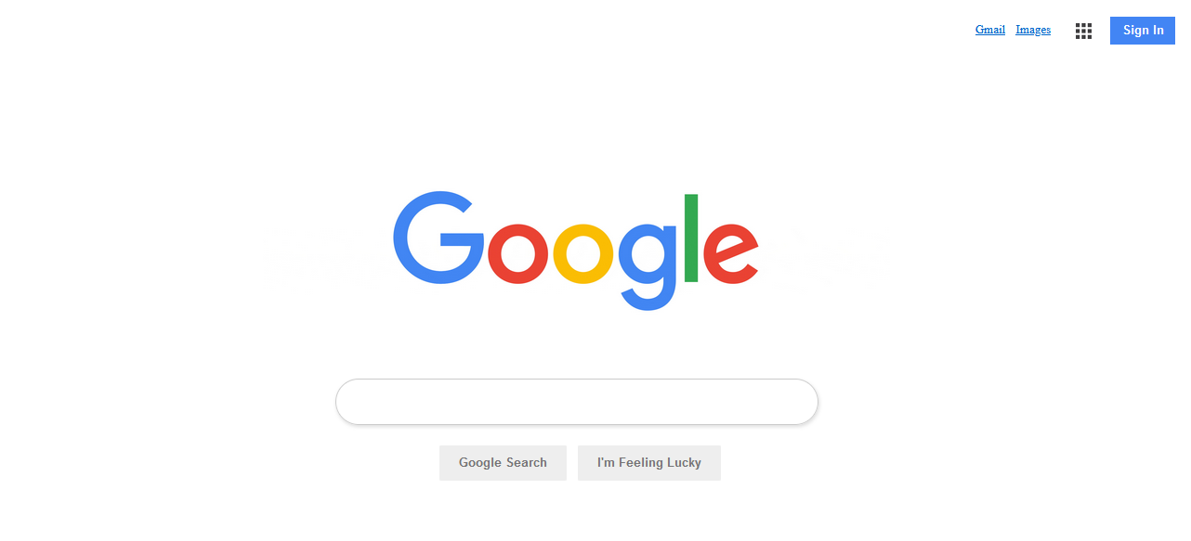**OUTPUT:**

**CREATE A GOOGLE FORM**

**HTML CODE:**

<!DOCTYPE html>

<html>

<body bgcolor=**"lightblue"**>

<centre></centre><img src=**"https://th.bing.com/th/id/OIP.w5Lr9lLEB-9Ft3W07qXPYQHaFF?w=260&h=180&c=7&r=0&o=5&pid=1.7"**></centre></body><br><br>

<centre><head class = **"h1"**> STUDENT GOOGLE FORM </head></centre>

<title >Student Form</title>

<link href=**"style2.css"** type=**"text/css"** rel=**"stylesheet"**>

<form>

<table>

<tr>

<td><b>Name:</td><td><input type = **"text"**></b></td>

</tr>

<tr>

<td><b>Reg .NO:</td><td><input type = **"text"**></td></b>

</tr>

<tr>

<td><b>Date oF Birth:<form action= **""**></td><td><input type = **"date"** name = **"D.O.B"**></td></b>

</tr>

<tr>

<td><b>E-Mail id:</td><td><input type = **"text"**></b></td>

</tr>

<tr><td>

<b>Gender:</b>

<td><input type=**"radio"** id=**"male"** name=**"gender"** value=**"male"**>

<label for=**"male"**>Male</label>

<input type=**"radio"** id=**"female"** name=**"gender"** value=**"female"**>

<label for=**"female"**>Female</label></td><br><br>

</td></tr>

<tr>

<td><b>Address:</td><td><textarea cols = **""**></textarea></td></b>

</tr>

<tr>

<td><b>Father's Name:</b></td><td><input type = **"text"**></td></b>

</tr>

<tr>

<td><b>Father's Occupation:</td><td><input type = **"text"**></td></b>

</tr>

<tr>

<td><b>Mother's Name:</td><td><input type = **"text"**></td></b>

</tr>

<tr>

<td><b>Mother's Occupation:</td><td><input type = **"text"**></td></b>

</tr>

<tr>

<td><b>Dept:</b></td>

<td><select id=**"Department"** name=**"Department"**>

<option value=**"Information technology"**>IT</option>

<option value=**"Computer Science Engineering"**>CSE</option>

<option value=**"EEE"**>EEE</option>

<option value=**"ECE"**>ECE</option>

<option value=**"Civil Engineering"**>Civil</option>

<option value=**"Mech"**>MECH</option></select>

</td></tr>

<tr> <td> <b>Degree:</td><td>

<input type = **"checkbox"** select id=**"degree"** name=**"Degree"**>

<option value=**"BE"**>B.E</option>

<input type = **"checkbox"** select id=**"degree"** name=**"Degree"**>

<option value=**"BTECH"**>B.TECH</option>

</tr>

<tr>

<td><b>Mobile No: </td><td><input type = **"text"**></td></b>

</tr>

<tr>

<td><b>10TH Mark:</td><td><input type = **"text"**></td></b>

</tr>

<tr>

<td><b>12TH Mark:</td><td><input type = **"text"**></td></b>

</tr>

<tr>

<td> <input type=**"submit"** value=**"Submit"**>

<input type=**"reset"** value=**"Reset"**></td>

</tr>

</table>

</form>

</body>

</html>

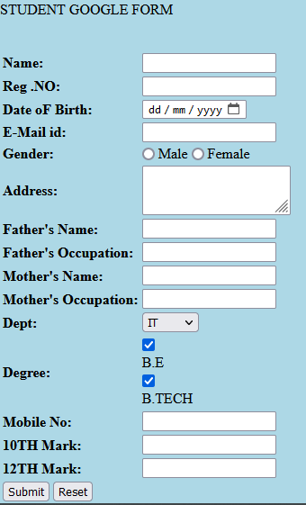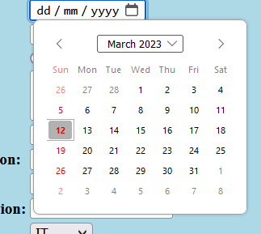**OUTPUT:**

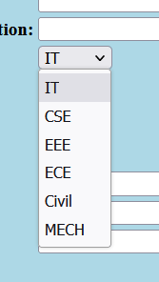

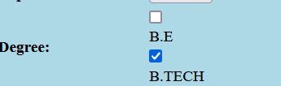

3.WEBPAGE WITH BACKGROUND IMAGE , PADDING & FONT PROPERTY

**HTML CODE:**

<!DOCTYPE html>

<html>

<head>

<meta name = **"viewport"** content=**"width=device-width, initial-scale=1.0"**>

<title>Avengers Assemble</title>

<link href=**"style4.css"** type=**"text/css"** rel=**"stylesheet"**>

</head>

<body>

<h1 style=**"box-sizing: content-box;"**> I am IRONMAN </h1>

<br>

<h2 style=**"text-align: center;"**>I am CAPTIAN AMERICA </h2>

<br>

<h3 style=**"text-align: left;"**>I am THE GOD THOR</h3>

<br>

<h4>I AM HULK</h4>

<br>

<br>

<h5> I am THANOS</h5>

</body>

</html>

**CSS CODE:**

body**{**

**background-image: url(**"images/marvel2.jpg"**);**

**background-attachment:scroll;**

**width:100%;**

**}**

h1**{**

**background-color: blue;**

**font-size: larger;**

**box-sizing: border-box;**

**text-align:left;**

**color: red;**

**background-color: rgb(44, 44, 42);**

**font-family:**'Times New Roman'**, Times, serif;**

**background-blend-mode:darken;**

**border: 4px solid rgb(229, 234, 235);**

**animation: 2s infinite;**

**animation-fill-mode:forwards;**

**animation-play-state:running;**

**}**

h2**{**

**font-size: large;**

**background-color: rgb(19, 19, 19);**

**color:rgb(31, 31, 211);**

**font-family:**'Times New Roman'**, Times, serif;**

**background-blend-mode:darken;**

**border: 4px solid rgb(229, 234, 235);**

**}**

h3**{**

**color:rgb(13, 230, 219);**

**background-blend-mode:darken;**

**background-color: rgb(7, 7, 7);**

**border: 4px solid rgb(223, 50, 50);**

**font-size:medium;**

**font-family:Georgia,** 'Times New Roman'**, Times, serif;**

**}**

h4**{**

**border: 4px solid rgb(229, 234, 235);**

**background-color: rgb(19, 19, 18);**

**color:rgb(31, 134, 31);**

**font-size: small;**

**font-family:**'Times New Roman'**, Times, serif ;**

**text-align: right;**

**}**

h5**{**

**background-blend-mode:darken;**

**border: 4px solid rgb(229, 234, 235);**

**background-color: rgb(10, 10, 10);**

**color:rgb(122, 6, 122);**

**font-size: smaller;**

**font-family:**'Times New Roman'**, Times, serif;**

**text-align: left;**

**}**

**OUTPUT:**

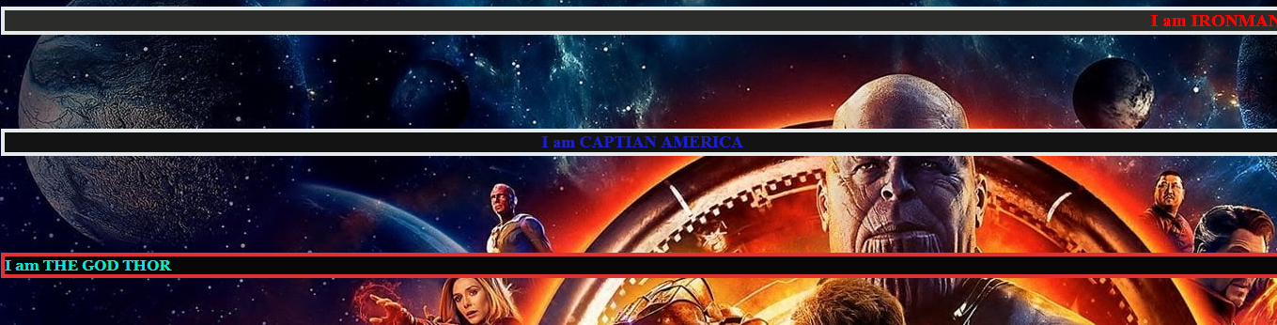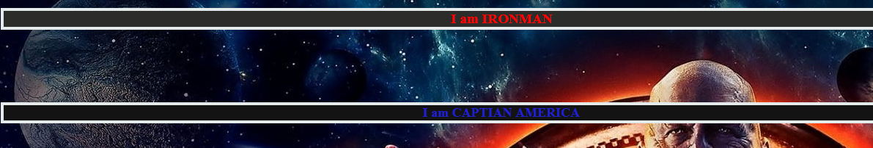 **Animation:**

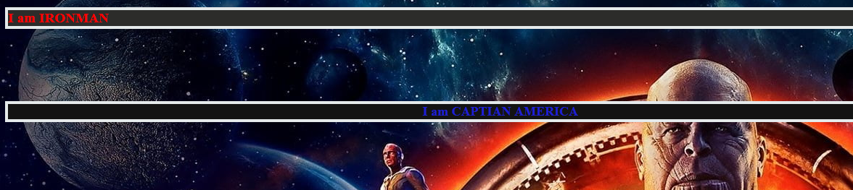

**Text-Alignment:**

